V—92:Services Overview:

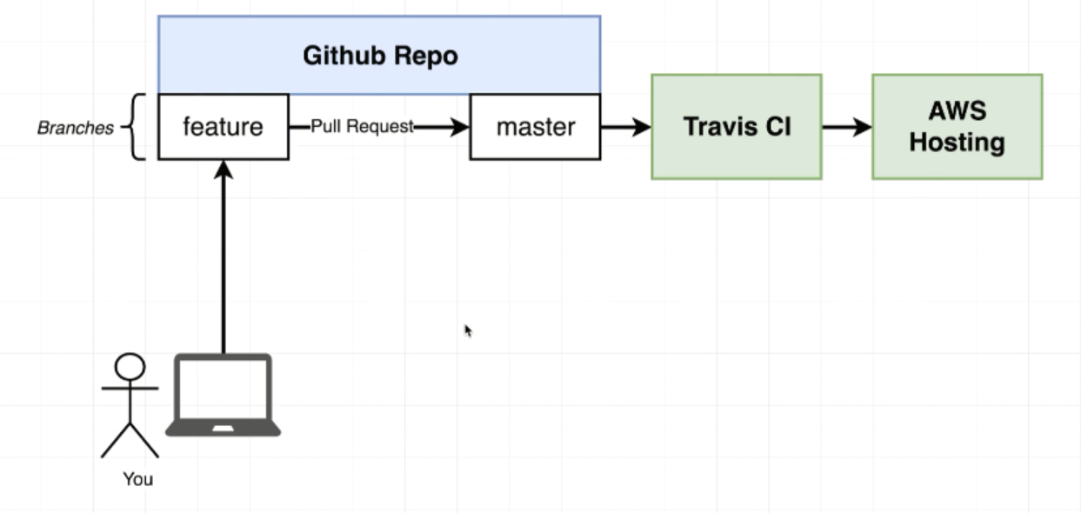

V—93:Github Setup:

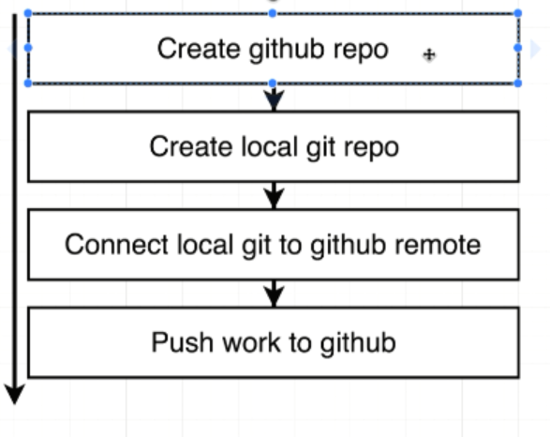

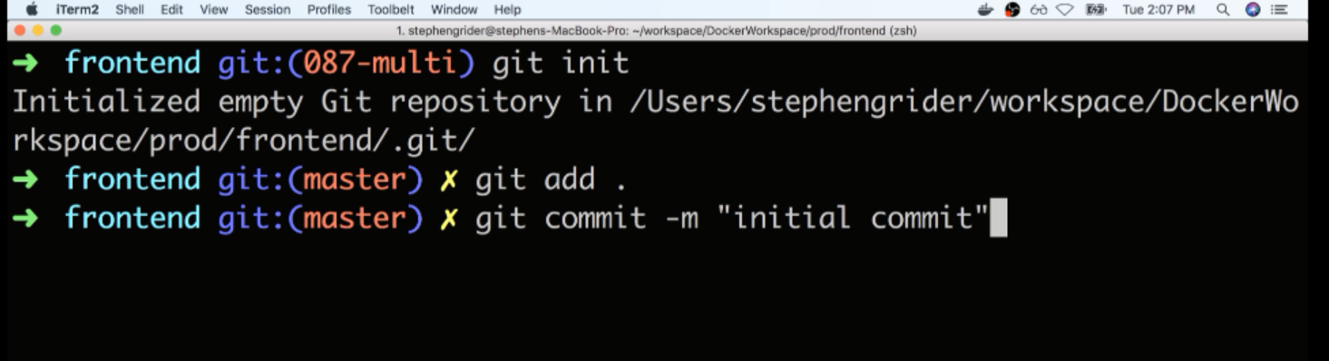

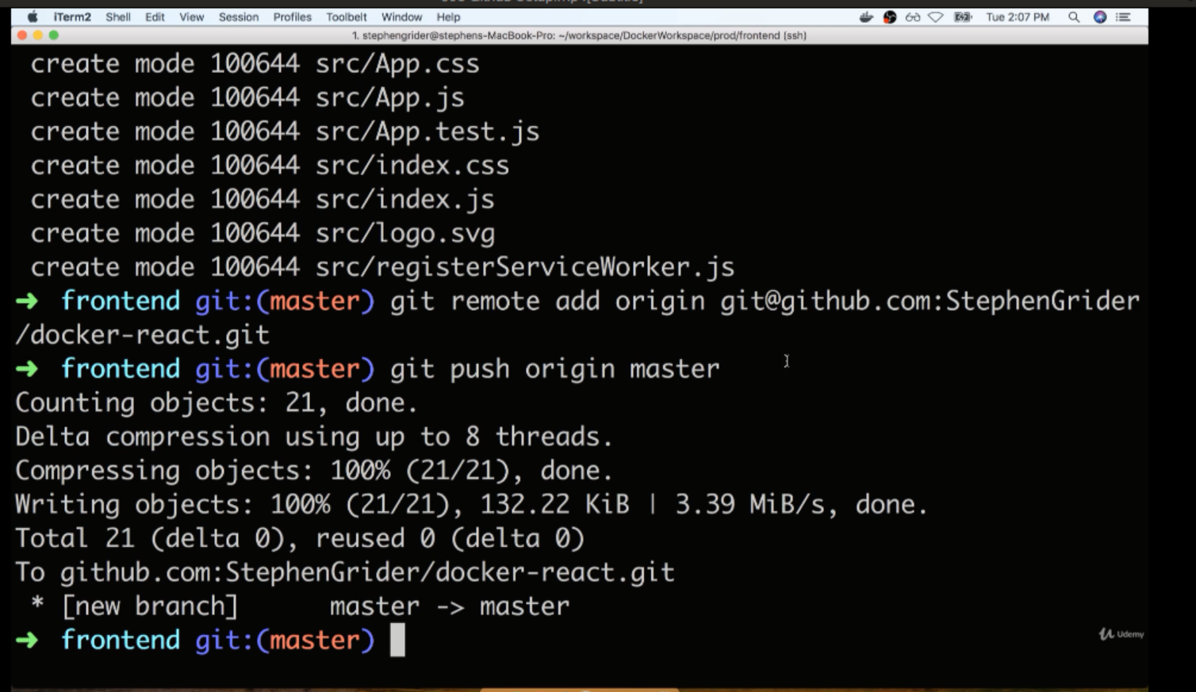

V—94:(Travis CI Setup):

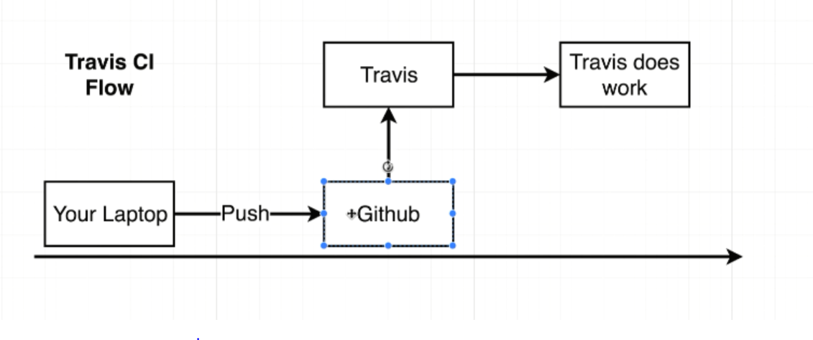

If we push some amount of code to the github project that we have just created anytime that we push up some code. Git hub essentially go and tap on the shoulders of travis and it’s going to say this person is just updated github repository. Travis CI will then automatically pull down all the code inside the our git hub repository. At that point that gives us some ability to do some work.

Traditionally people use travis for testing or code base or for deployment. First we use travis to test our code and then once test passed successfully then will automatically have travis deployer application over to AWS.

Steps to integrate github repository and travis CI.

V—95:(Travis YML configuration):

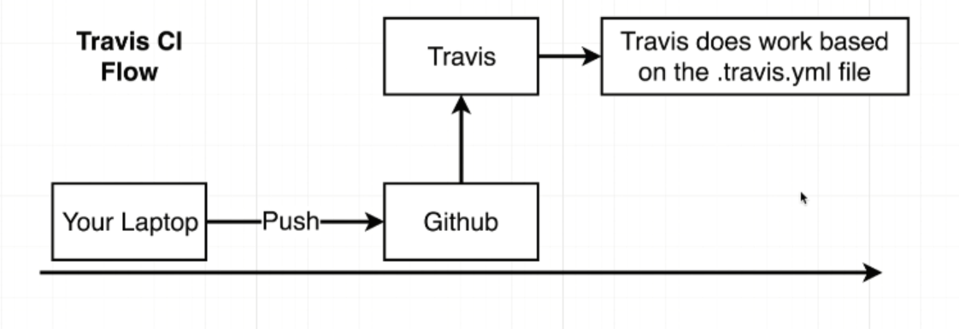

.travis.yml file to be created in root folder. We are going to have series of directions to tell travis exactly what we wanted to do.

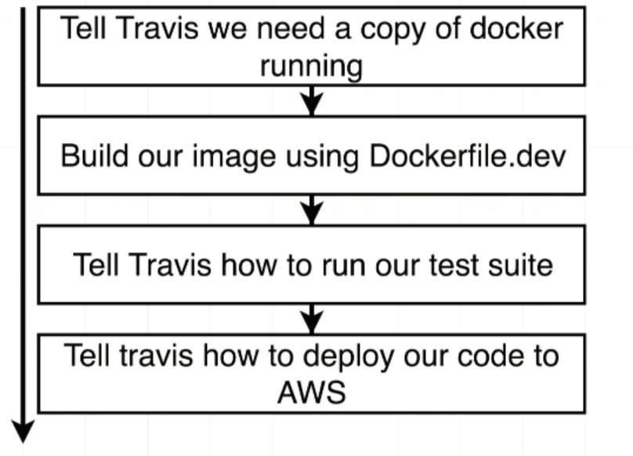

Before install : contains the statements that executed before our tests run. Contins the series of statements are setup that needs to occur before we start to either deploy our project or before we start to run our tests.

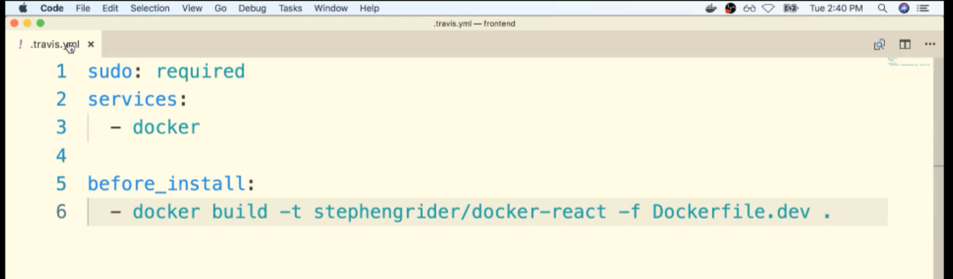

-f Dockerfile.dev .

V—96:(Required Travis updates)

In the upcoming lecture we will be adding a script to our .travis.yml file. Due to a change in how the Jest library works with Create React App, we need to make a small modification:

script:  
 - docker run USERNAME/docker-react npm run test -- --coverage

instead should be:

script:  
 - docker run -e CI=true USERNAME/docker-react npm run test

Additionally, you may want to set the following property to the top of your .travis.yml file:

language: generic

You can read up on the CI=true variable here:

<https://facebook.github.io/create-react-app/docs/running-tests#linux-macos-bash>

and enviornment variables in Docker here:

<https://docs.docker.com/engine/reference/run/#env-environment-variables>

V—97:(Touch More Travis Setup):

Scripts section contains commands that need to be executed to actually run our test suite.

Travis CI is going to be watching the output of each of these commands and from each command if it ever gets a return status code other than zero. Travis is going to assume that our build failed or our test suite failed to run properly.

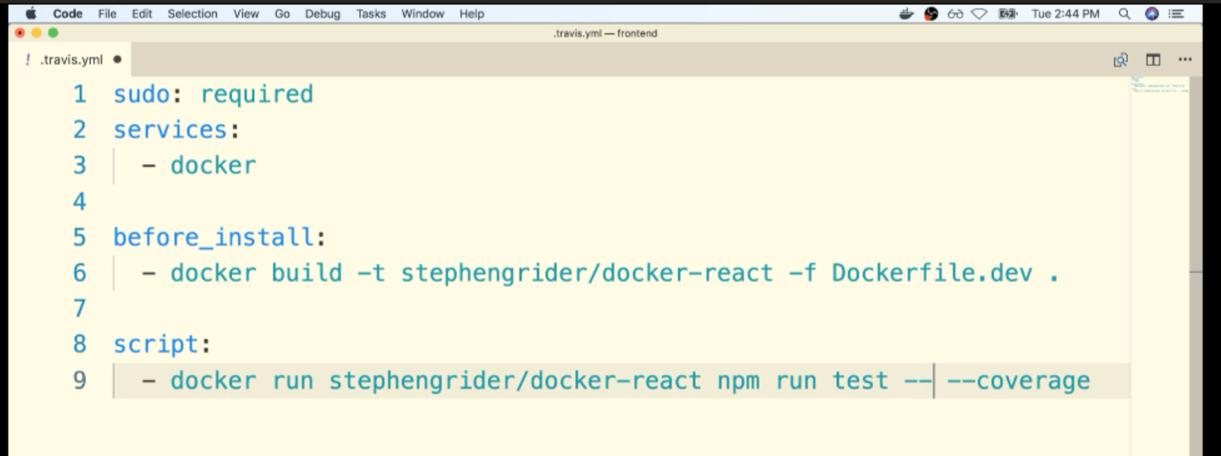

-- -- coverage is just to exit the npm run test after own attempt

V—98:(Automatic Build Creation):

Commit the changes we made locally push that code to GitHub. And travis should essentially take it from there.

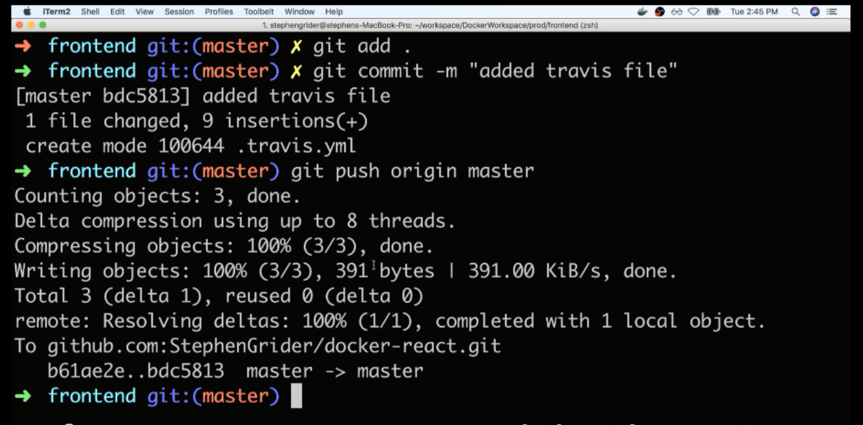

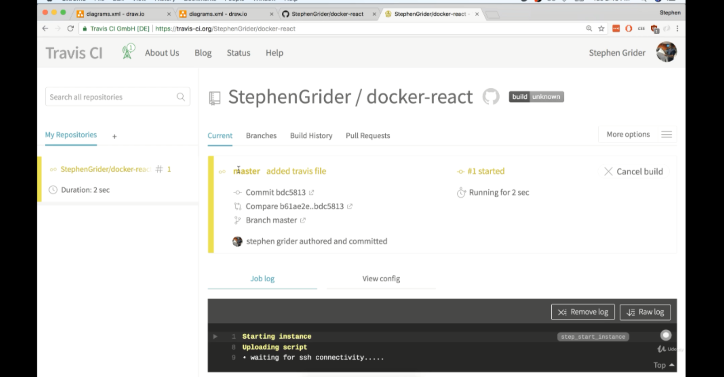

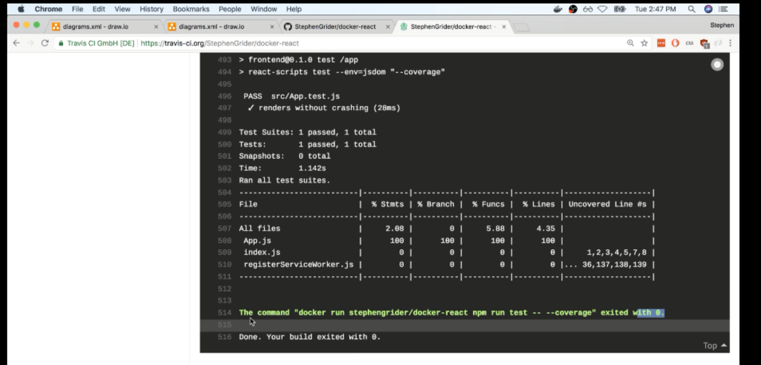

Exited with 0 means everything ran successfully.

V—99:(Important Info about AWS Platform Versions):

updated 10-8-2020

On October 6, [AWS made some significant platform changes](https://forums.aws.amazon.com/ann.jspa?annID=8136) that will affect our single container application. Among these changes was adding the full support of using Docker Compose to provision a production AWS environment. This means that Elastic Beanstalk will no longer first look for a Dockerfile, it will first look for a docker-compose file and attempt to build and run a container from it.

**When creating our Elastic Beanstalk environment in the next lecture, we need to select Docker running on 64bit Amazon Linux** instead of Docker running on 64bit Amazon Linux 2. This will ensure that our container is built using the Dockerfile and not the compose file.

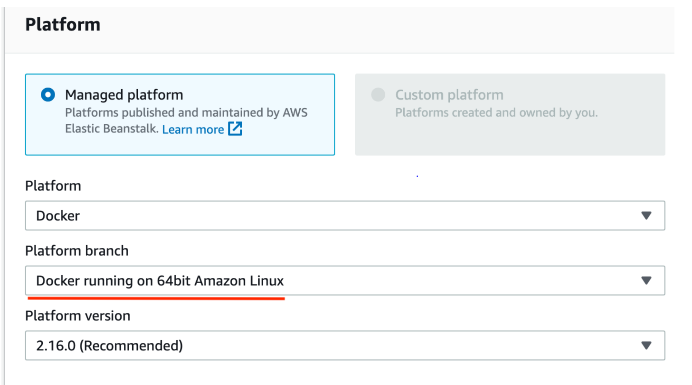

V—100:(AWS Elastic BeanStalk):

Now our application is ready to be deployed to some outside hosting providers such as AWS or windows user or Digital Ocean etc…

Now we are going to setup some automatic deployments over to AWS.

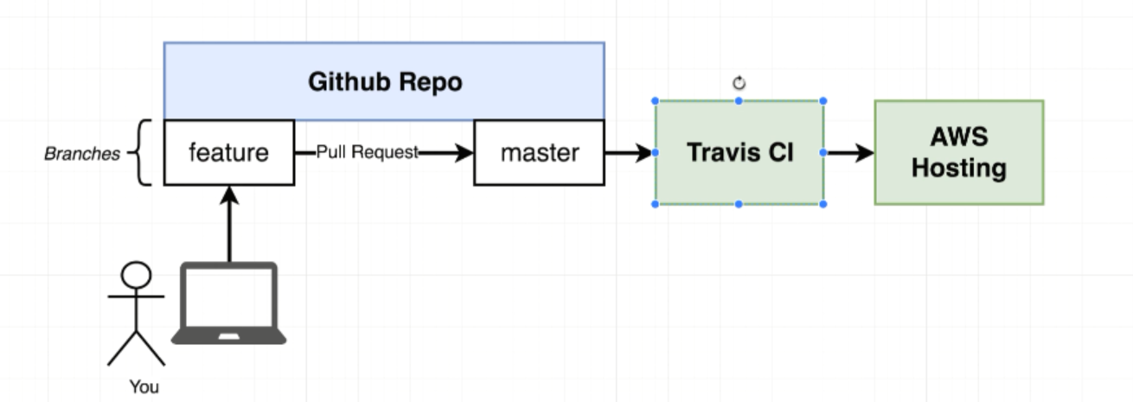

Easiest way to get started with production docker instances.

EBS Dashboard:

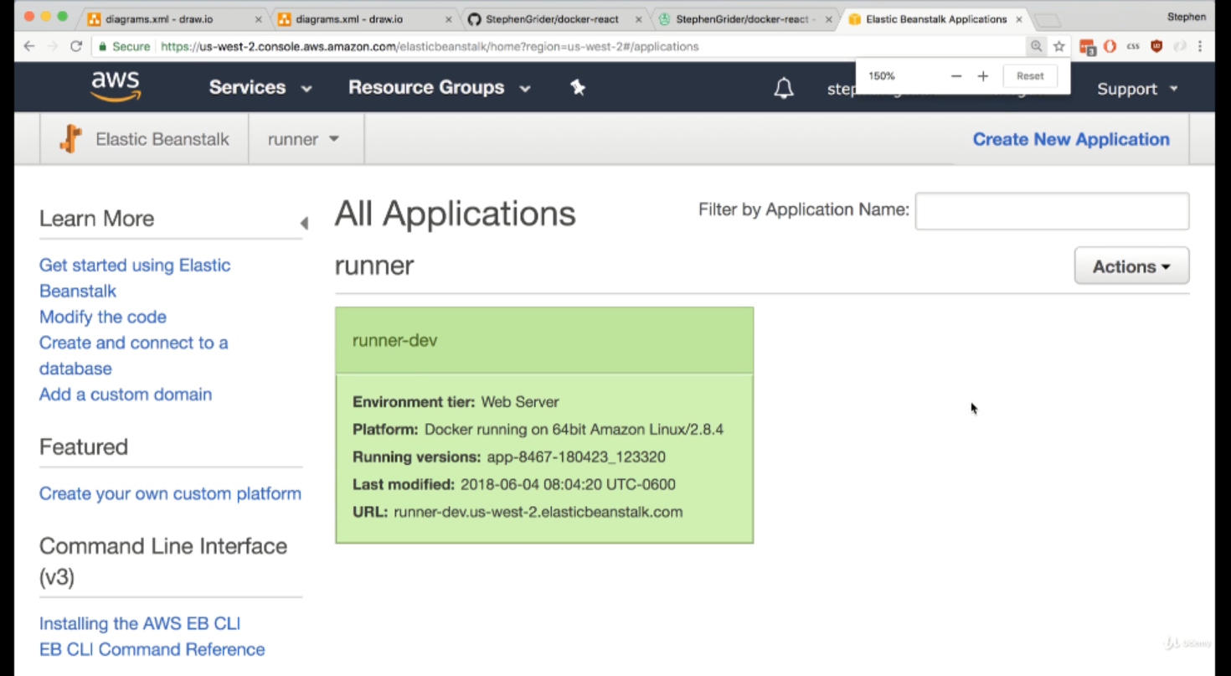

Click on create New Application which is on right hand top corner

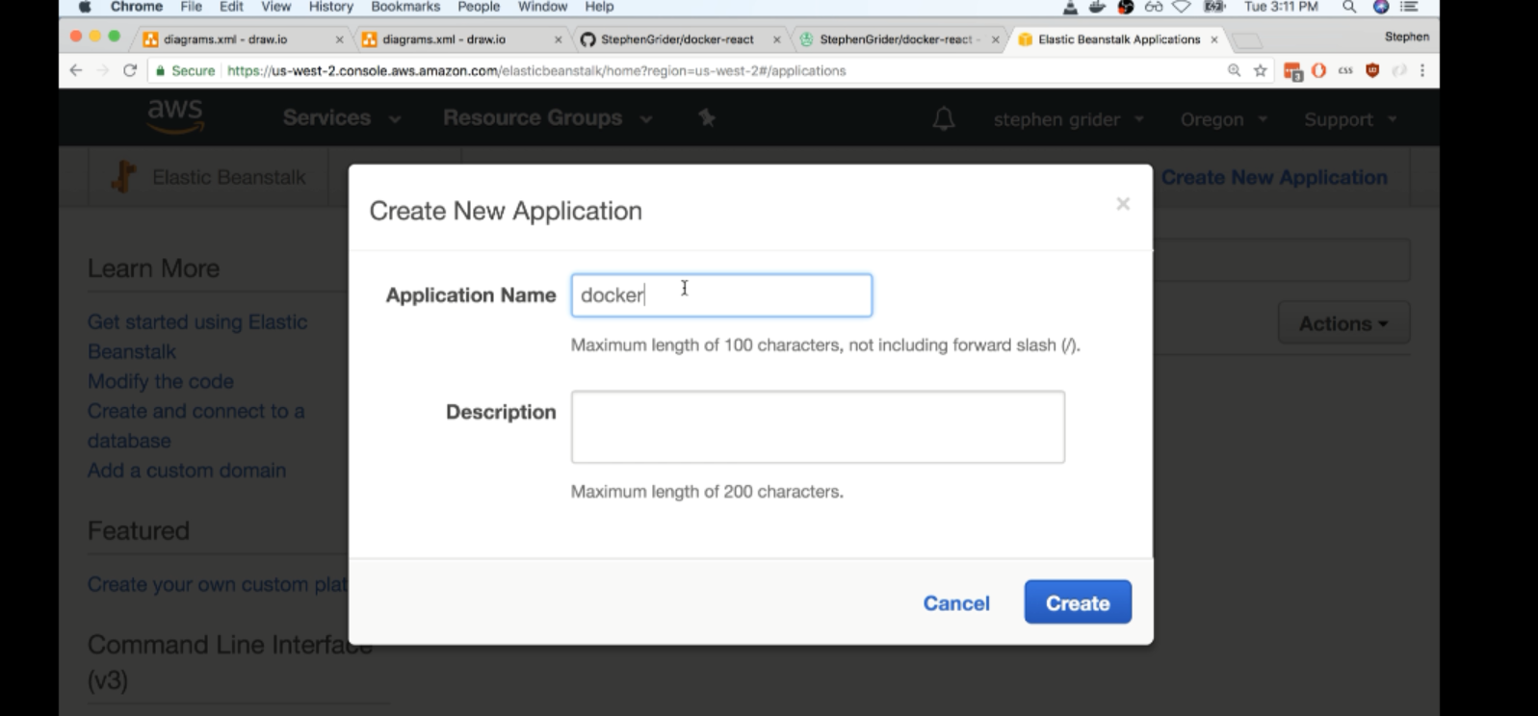

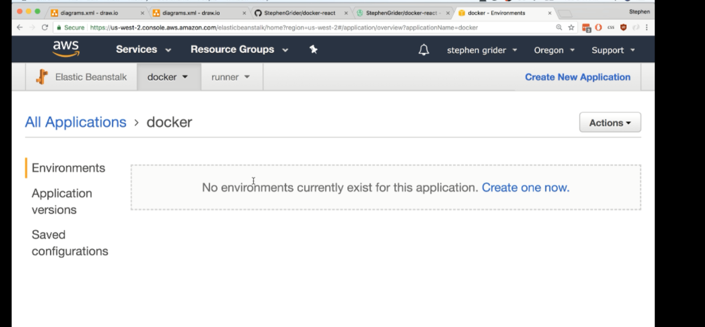

Click on create on now

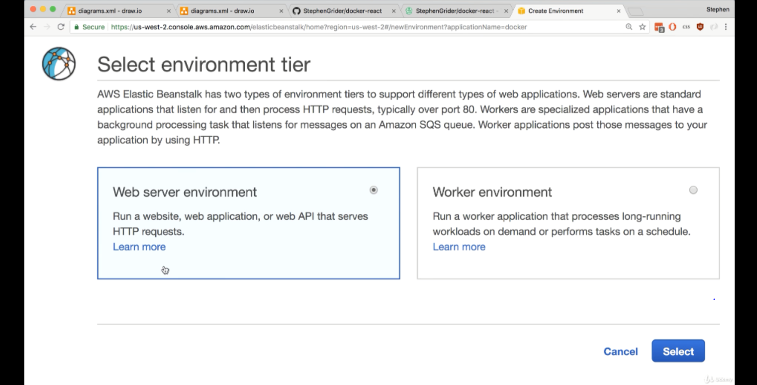

Click on select

Choose platform as Docker

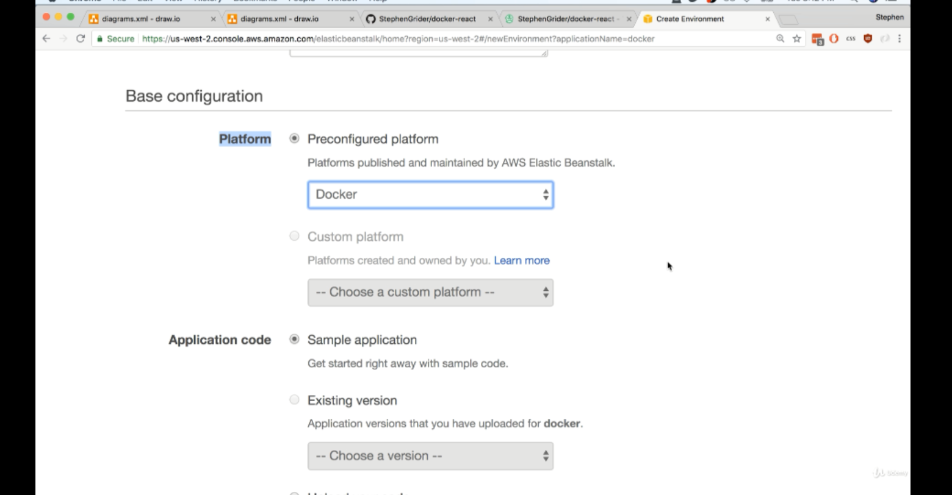

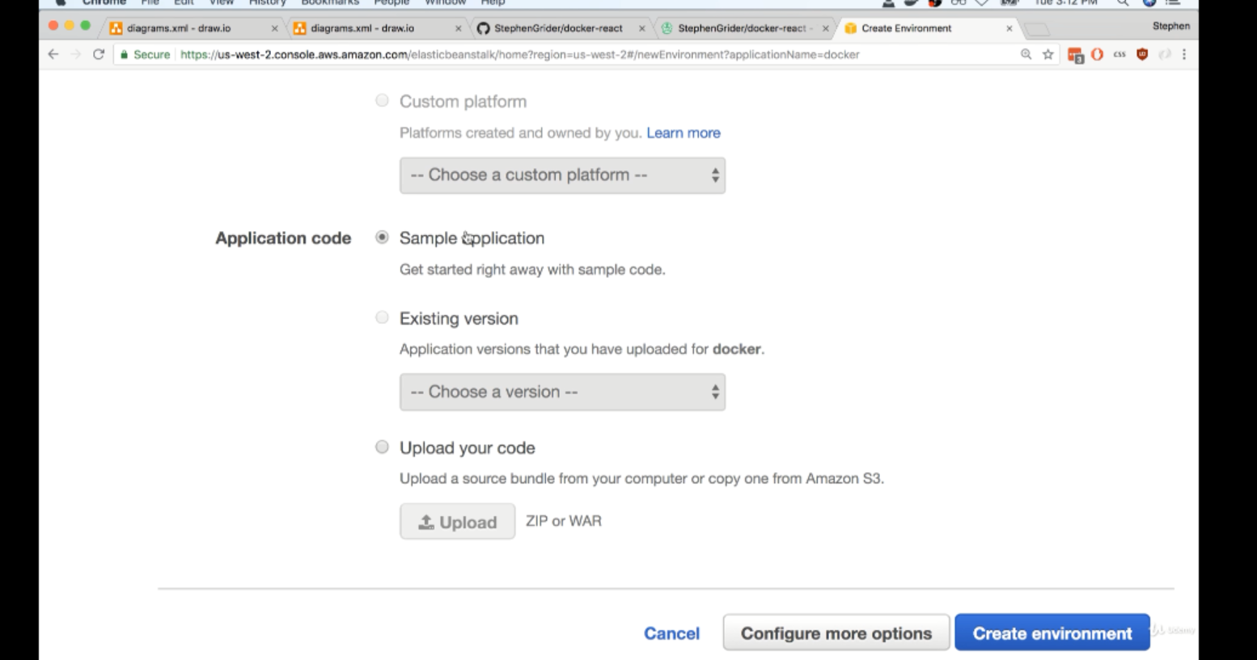

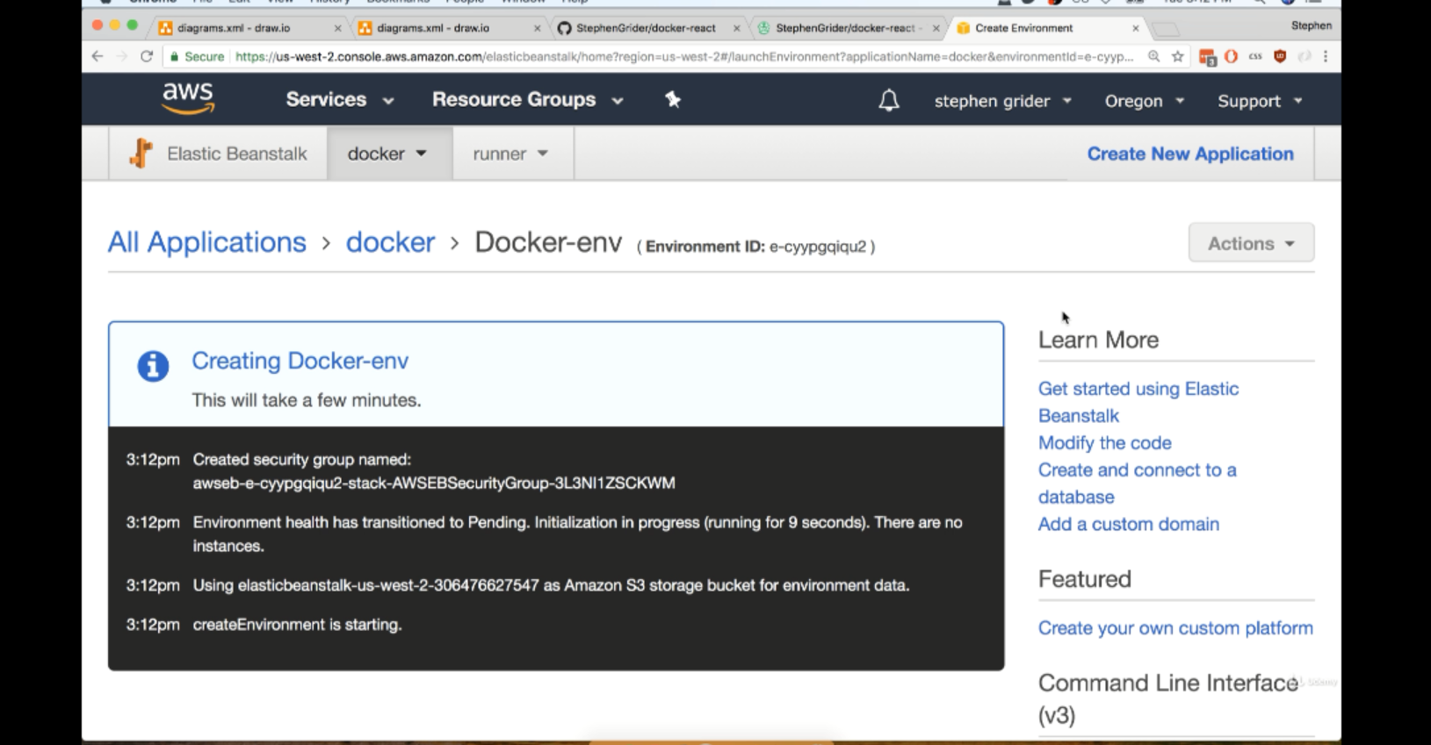

V—101:(More on Elastic BeanStalk):

This is how it looks:

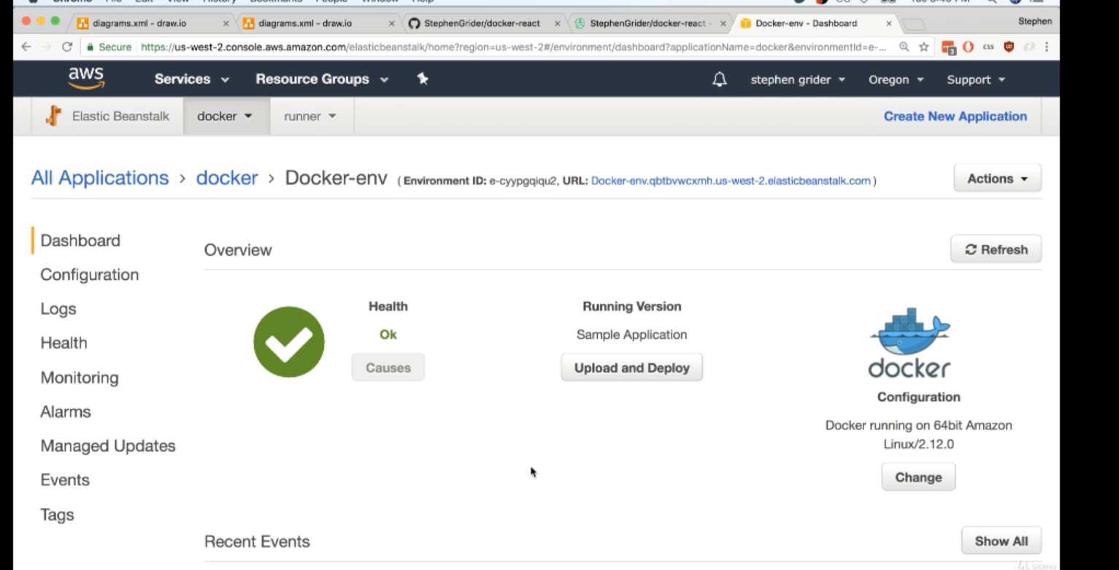

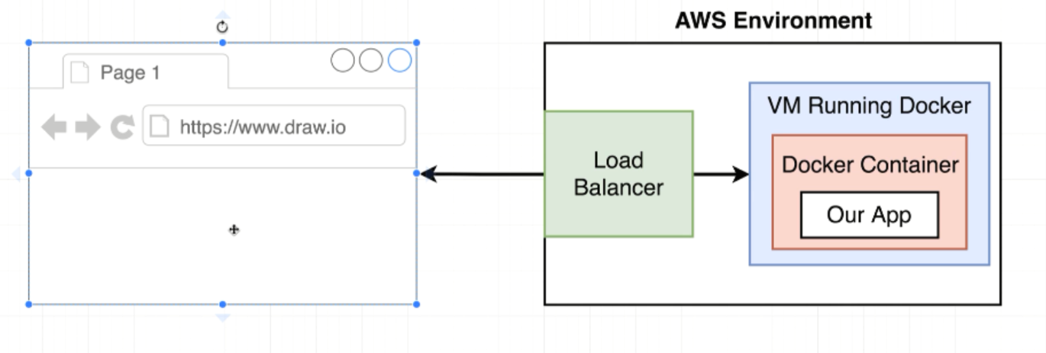

When we give url, that means we attempt to navigate to our website. The request will be handled by a load balancer that has already been created as a part of the elastic beanstalk application.

The load balancer will allow that request to a virtual machine that is running docker and on that virtual machine our docker container will be running with our application inside of it.

The benefits of Beanstalker is that it monitors the amount of traffic that comes into our virtual machine right here.And as soon as traffic reaches a certain threshold elastic bean stalk is going to automatically add in additional virtual machines to handle the traffic.

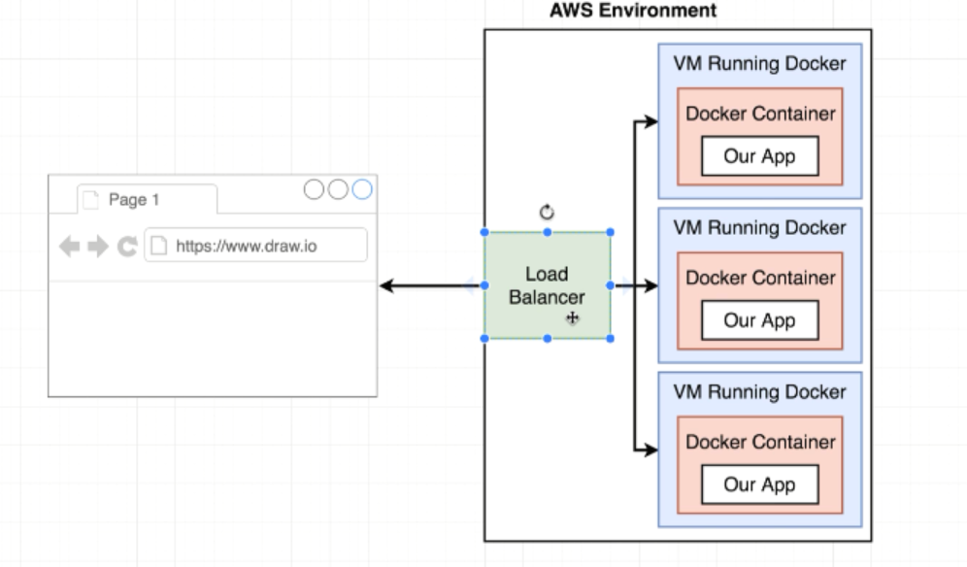wire it up to travis CI instance.

V—102:(Travis Config for Deployment):

Deploy section to tell how to take our application and deploy it off to AWS Application.

Travis config is preconfigured to deploy our application to a handful of different providers or hosting providers such as AWS or Digital Ocean etc.

By providing provider : elastcbeanstalk We are essentially telling travis CI hey we want you to attempt the following instructions to automatically deploy our application.

When you create a particular elastic bean stalk, you created it in a particular region.

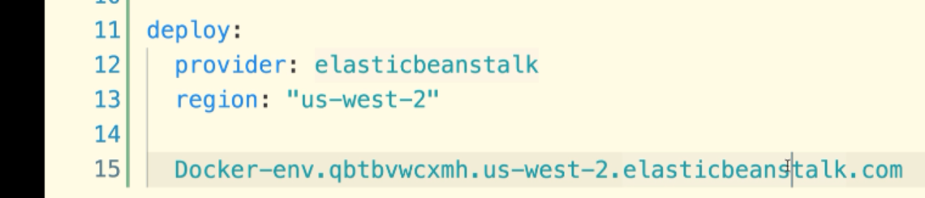

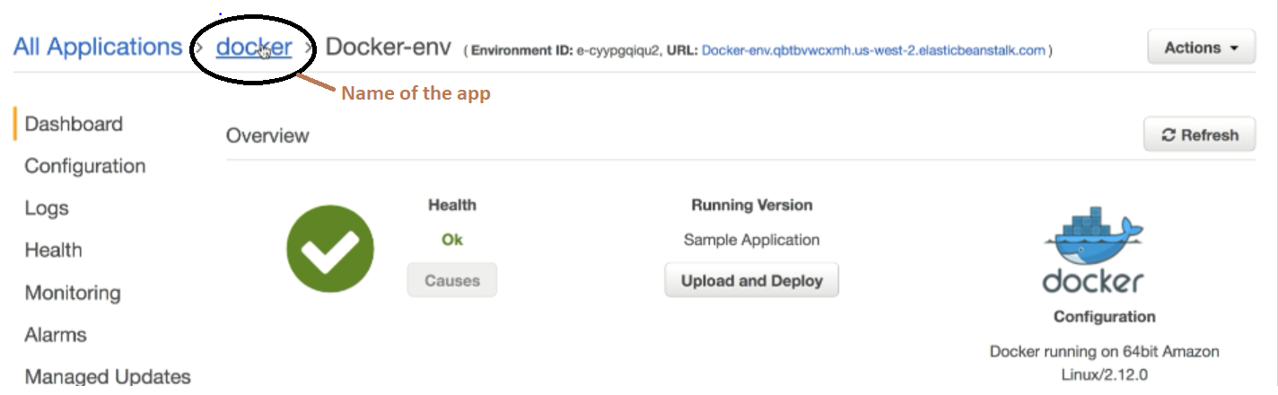

When travis decides to deploy our codebase it’s going to take all the files inside github repository and then zip it up into a one single file and then it’s gonna copy all them over a S# bucker which is essentially a harddrive running on AWS.

Once it copies all those files, Travis CI essentially poke at a elasticbeanstalk and say Hey I just uploaded this new zip file. Use that to redeploy our application.we need to provide the name of the bucket that travis CI is going to put our zip file into.

There is an S3 bucket automatically generated for us when you initially created the elasticbeanstalk instance.

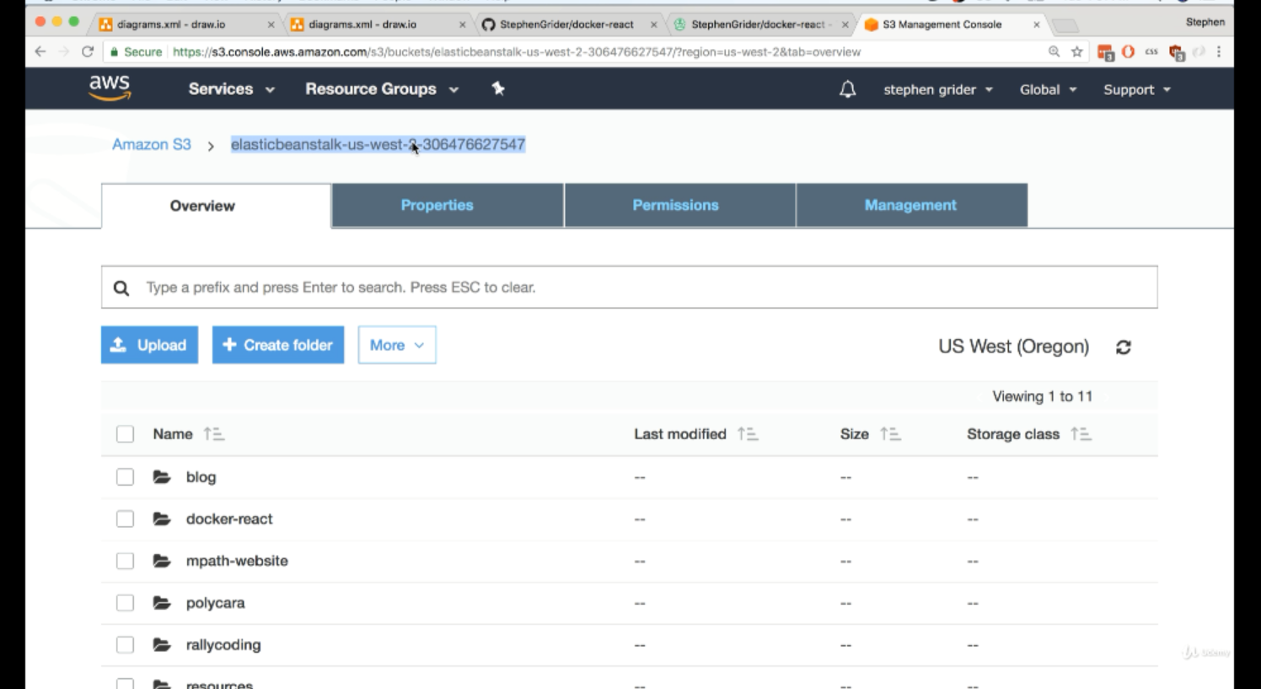

Bucket_path is exactly same as app

Attempt to deploy only master branch has some new code.

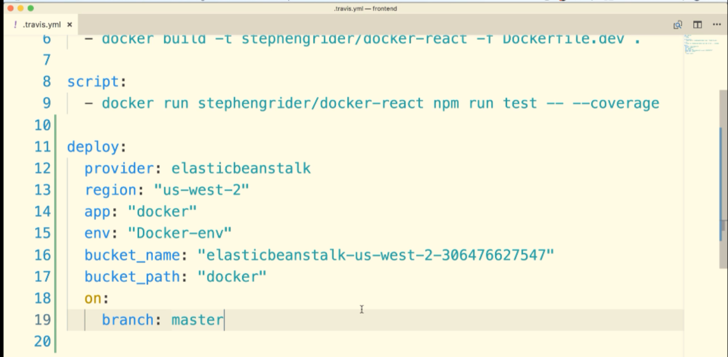

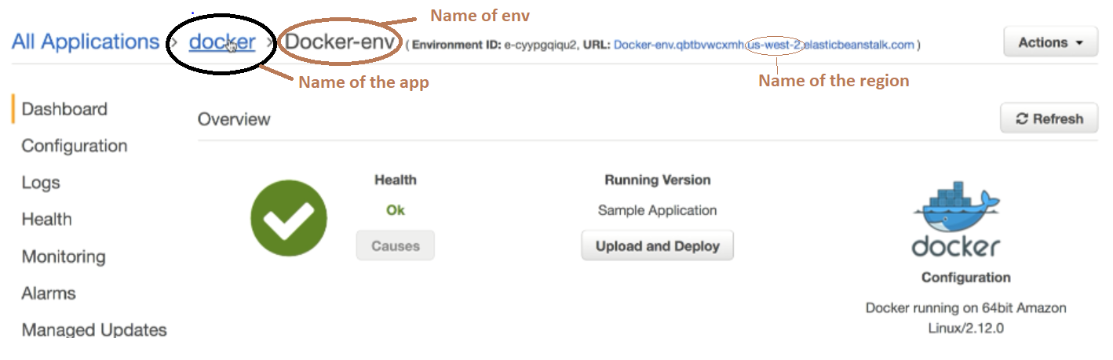

V—103:(Travis Keys Update):

In the upcoming lecture we will be adding our AWS variables to the deploy script of the .travis.yml file. There is a slight change that will be required, otherwise you will get an error when Travis attempts to run your code.

The code will now look like this:

access_key_id: $AWS_ACCESS_KEY  
secret_access_key: $AWS_SECRET_KEY

V—104:(Automated Deployment):

We have to add in set of API keys that are going to give access to our AWS Account over to Travis CI.

IAM is the service that is used to manage API keys that can used by outside services.

Create a user that gonna used by travis CI.

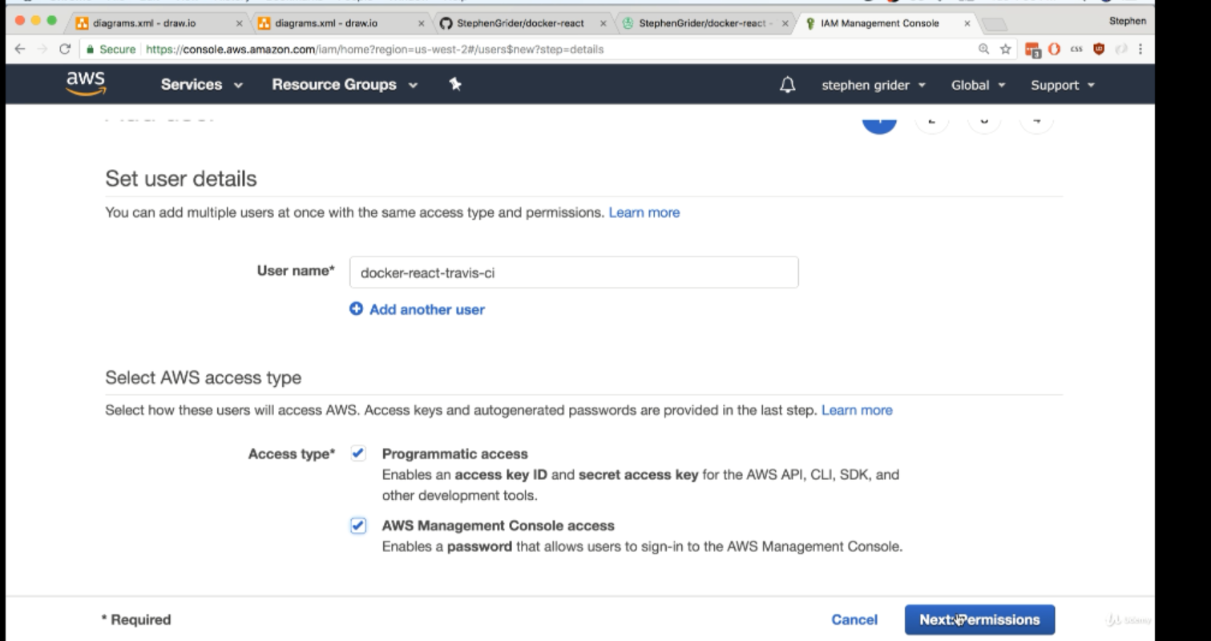

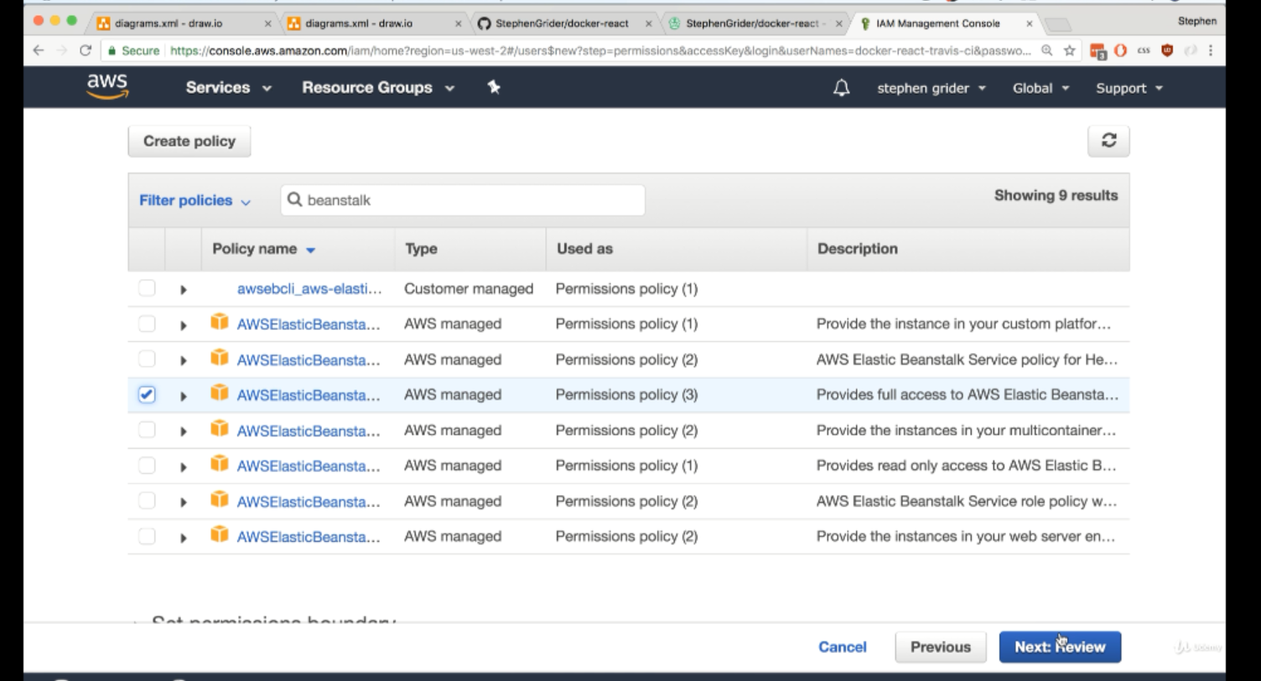

Attach policies click on Review and then click on Review

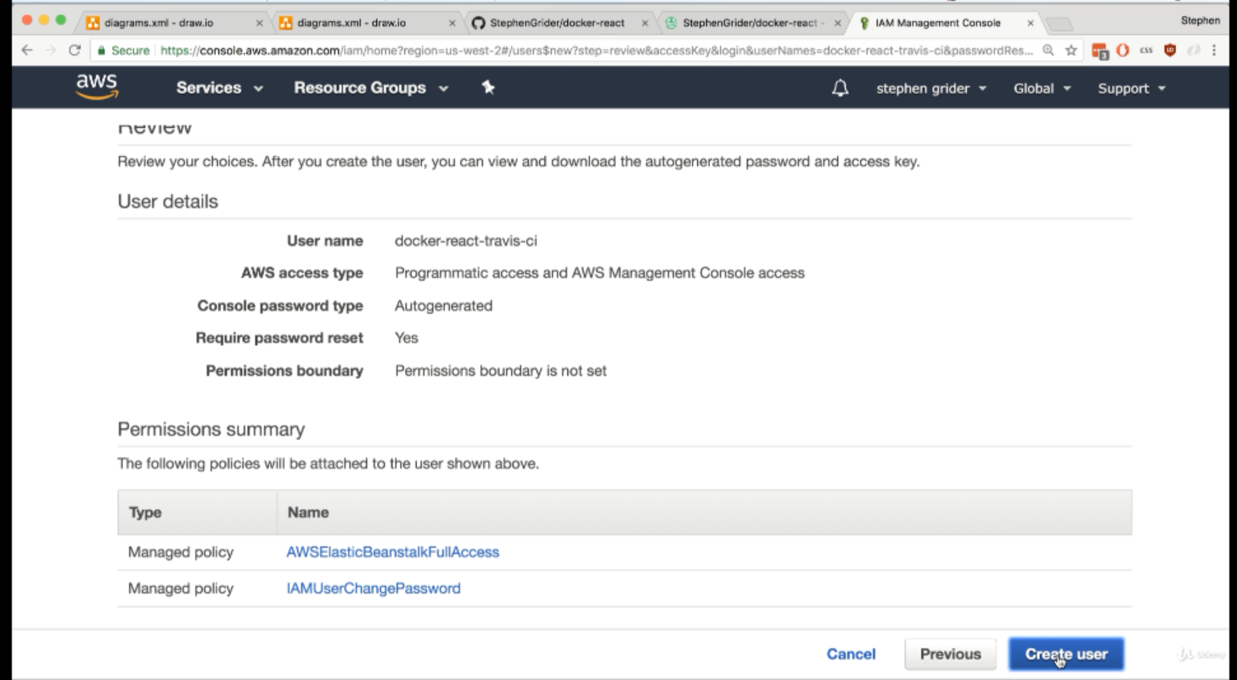

Click on Create user

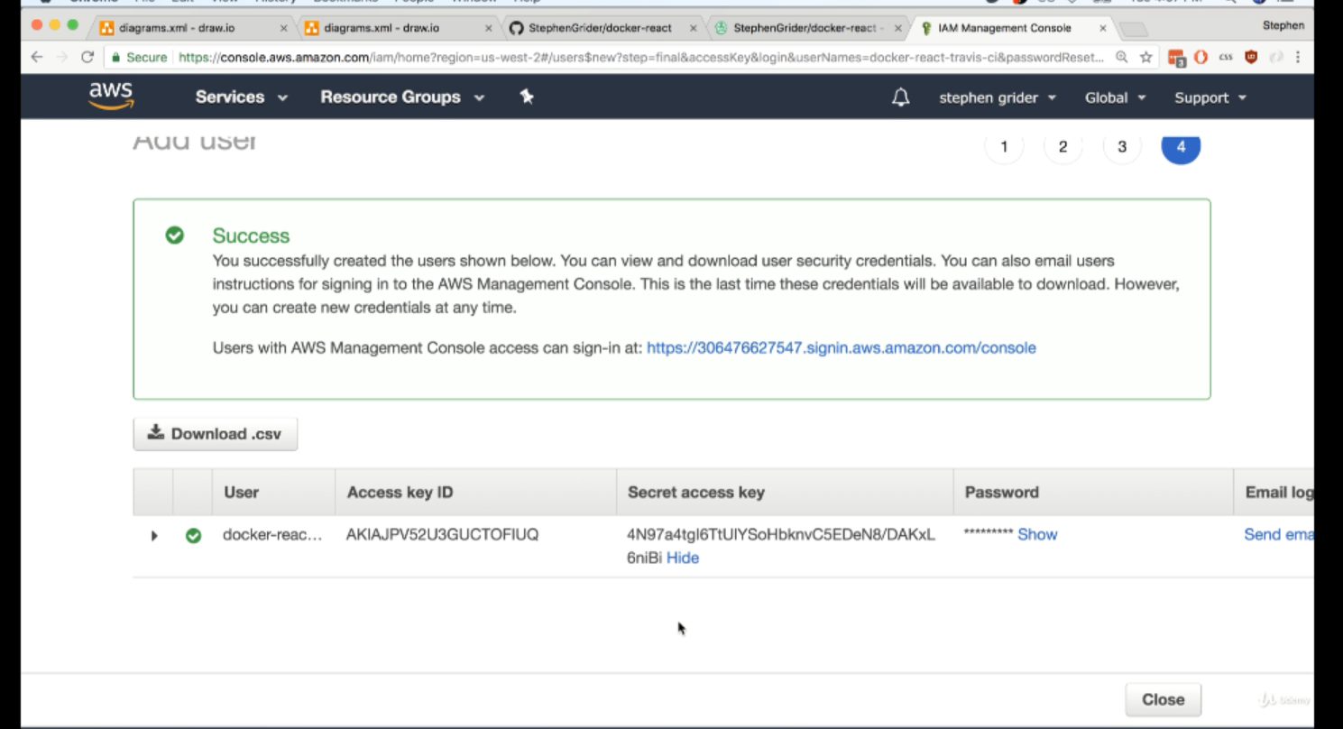

Travis CI> settings >> environment variables

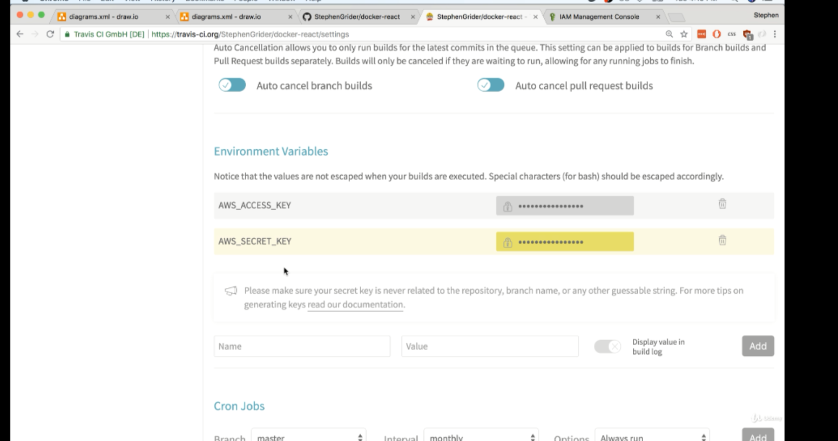

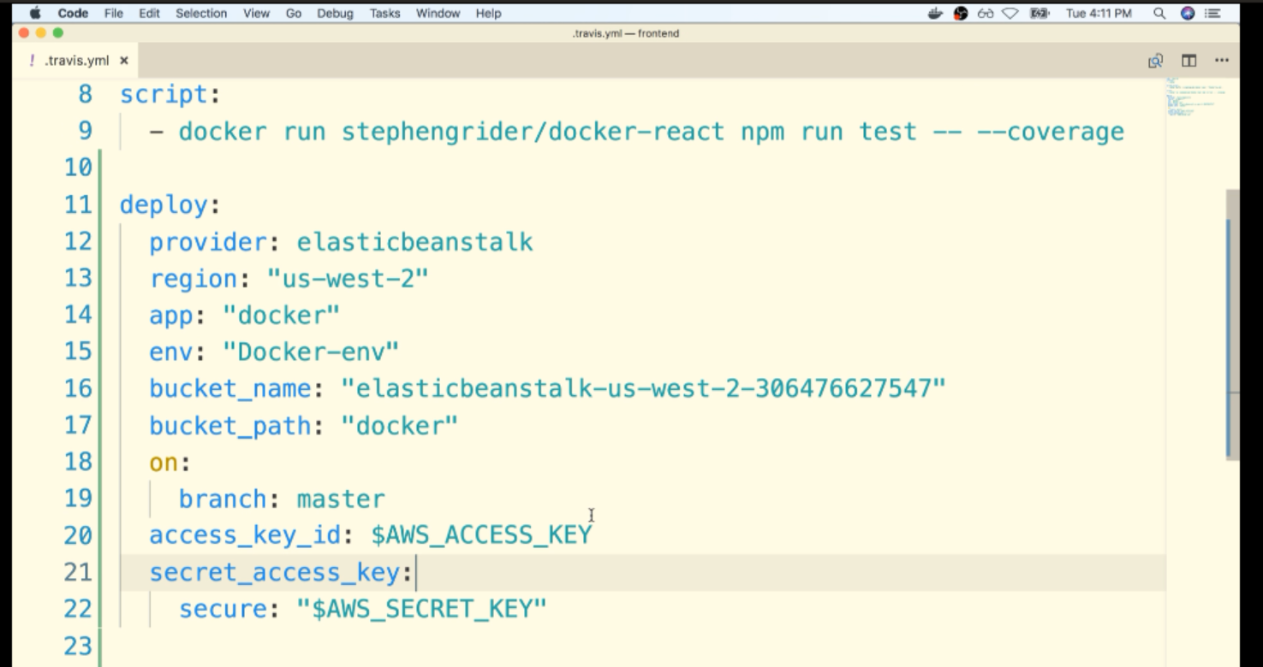

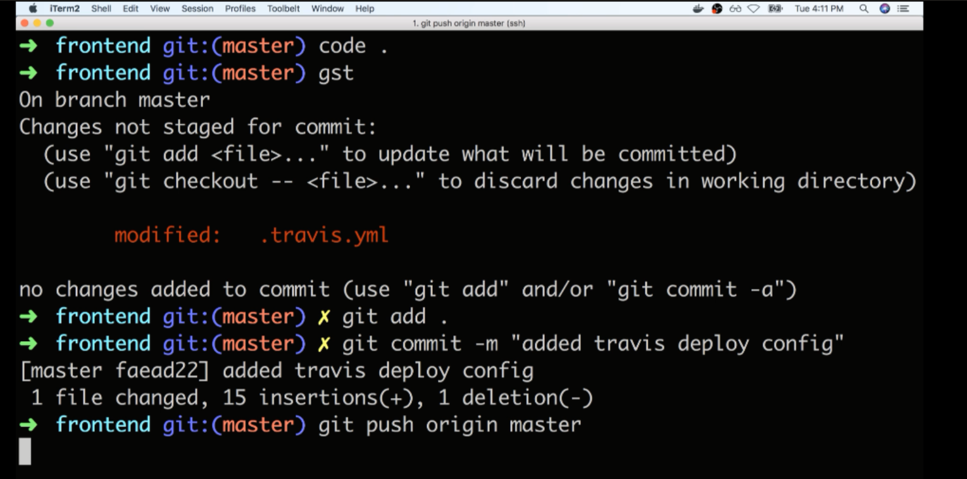

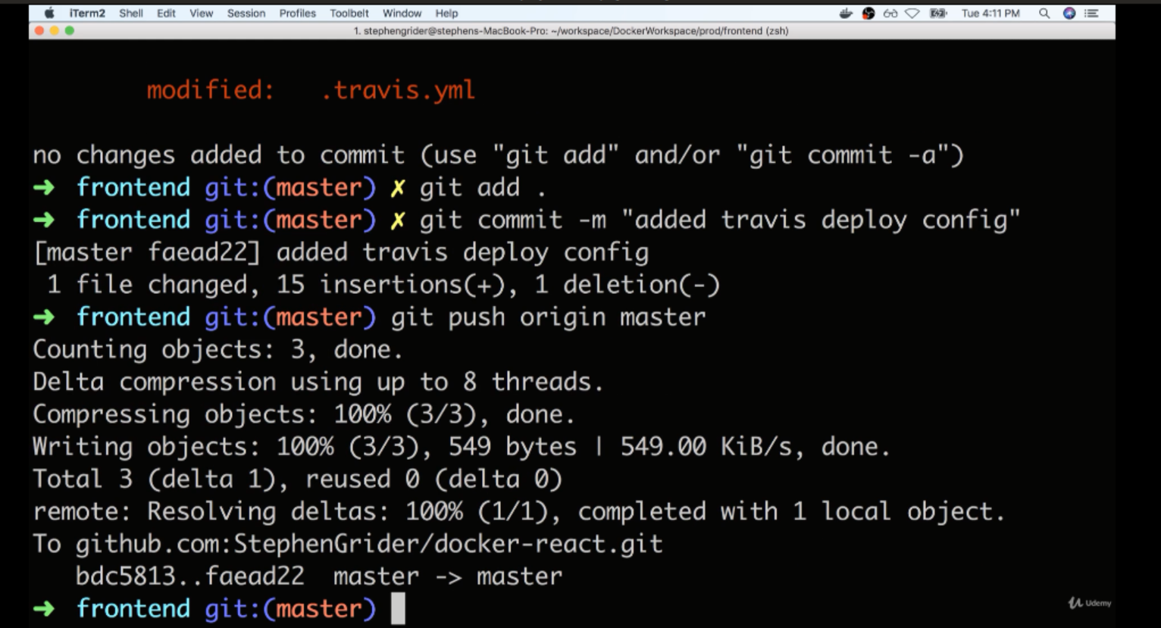

V—104:(Exposing Ports Through Docker file):

We need to expose the port on Elastic Bean Stalk.

Expose 80 means the container is probably needs to get a port mapped to port 80.

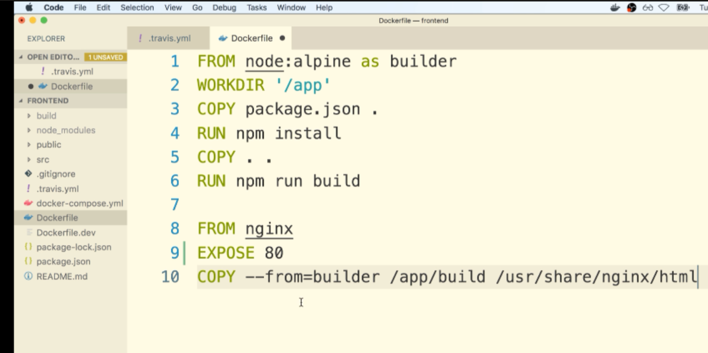

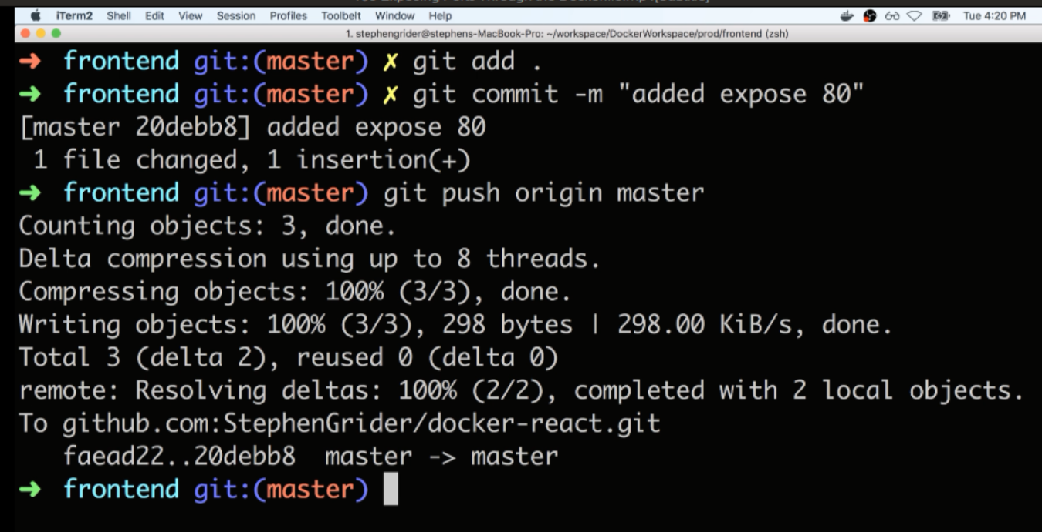

V—107:(Workflow with Github):

Commit changes to a feature branch. Push it to github. Make the pull request and merge that thing into master.

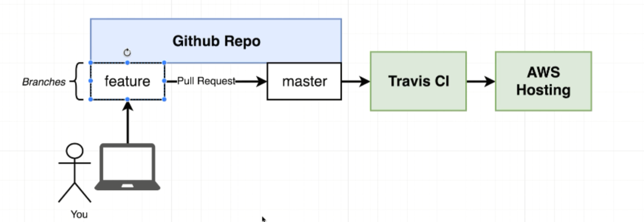

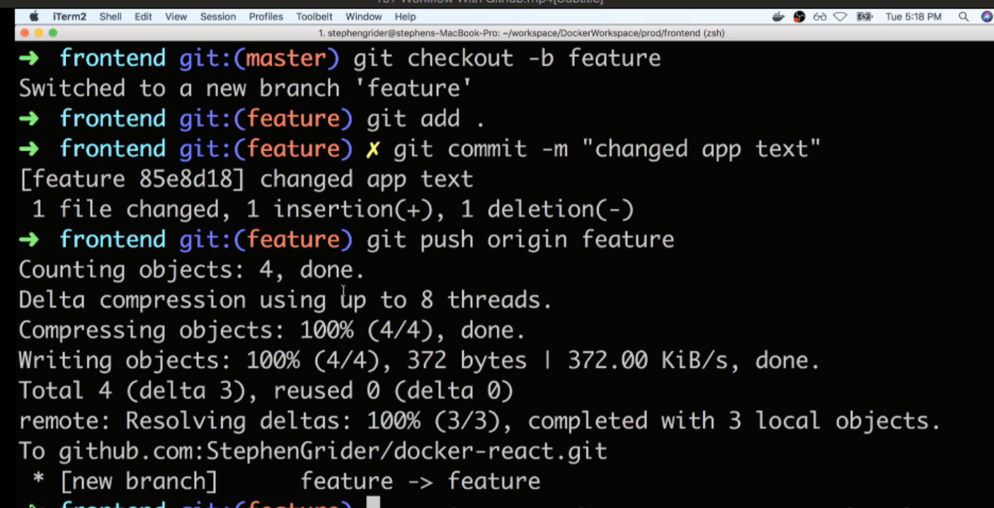

Open git hub click on compare & pull request to pull code from feature branch

V—108:(Redeploy on Pull Request Merge):

V—109:(Redeployment Wrap):